The Stroop Effect

By Brenda Ruch

The Stroop Effect

1. **What is our independent variable? What is our dependent variable?**

Our independent variable is the congruency between the meaning of the words and the color of the font in which the words are displayed. Our dependent variable is the number of seconds it takes to identify the color of the font out loud.

1. **What is an appropriate set of hypotheses for this task? What kind of statistical test do you expect to perform? Justify your choices.**

My null hypothesis is that making the color and the meaning of the word incongruent will either reduce the amount of time in the participant’s post-test responses or have no effect on them at all. My alternative hypothesis is that changing the congruency will have a positive effect on the amount of time it takes to identify the colors out loud.

H0: µi - µc ≤ 0

Ha: µi - µc > 0

H0 = null hypothesis

Ha = alternative hypothesis

µi = the predicted population mean of the results from an incongruent Stroop test

µc = the predicted population mean of the results from a congruent Stroop test

I expect to perform a left-tailed t-test on this data because this experiment involves pre- and post-test samples on individuals with no known population parameters. When using a t-test, one assumes the following: the sample is a random selection from the population, the population will have a normal distribution of results, the variance of the sample data can be used to estimate the variance of the population, and that the population variances are roughly equal.

1. **Report some descriptive statistics regarding this dataset. Include at least one measure of central tendency and at least one measure of variability.**

I found a mean difference of 7.9648 seconds with a standard deviation of 4.8648 between the incongruent and congruent tests.

1. **Provide one or two visualizations that show the distribution of the sample data. Write one or two sentences noting what you observe about the plot or plots.**

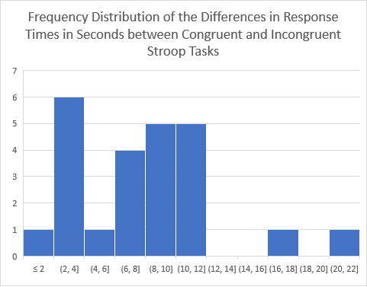

This histogram shows a positively skewed distribution. The plurality of participants in the sample spent 2-4 more seconds finishing the incongruent task than they spent on the congruent task.

1. **Now, perform the statistical test and report your results. What is your confidence level and your critical statistic value? Do you reject the null hypothesis or fail to reject it? Come to a conclusion in terms of the experiment task. Did the results match up with your expectations?**

My confidence level is at 0.05, and my degrees of freedom are 23, which gives me a t-critical value of 2.0690. (“t-table.pdf,” n.d.) My sample mean has a t-score of 8.0248, which is higher than my t-critical value. My p-value for this t-statistic is less than .0002. Therefore, I can reject the null hypothesis. With this sample, I can conclude with 95% confidence that the mean difference in the population will be between 5.9103 and 10.019 seconds. The results were as I predicted.

1. **Optional: What do you think is responsible for the effects observed? Can you think of an alternative or similar task that would result in a similar effect? Some research about the problem will be helpful for thinking about these two questions!**

After reading a few abstracts made available through my local library, I think that the Stroop Effect is caused by the brain’s tendency to prioritize certain kinds of information over others. (Zunick, Granados Samayoa, & Fazio, 2017) In this version of the test, the brain prioritizes the meaning of the written word over the perceived color of the word, even though we’re consciously aware that we need the color to complete the Stroop Task. I found an interesting study where people were asked to identify emotions when someone expressed them in a short sentence, like, “I feel happy.” In the congruent test, someone would say the sentence in the tone of voice that expresses the emotion. In the incongruent test, someone would use a tone expressing a different emotion from what is expressed in the sentence. Imagine Eeyore saying, “I feel happy.” It resulted in a similar effect to the Stroop Test observed in this study. (Filippi et al., 2017)

Bibliography

Filippi, P., Ocklenburg, S., Bowling, D. L., Heege, L., Güntürkün, O., Newen, A., & de Boer, B. (2017). More than words (and faces): evidence for a Stroop effect of prosody in emotion word processing. *Cognition & Emotion*, *31*(5), 879–891.

t-table.pdf. (n.d.). Retrieved from http://www.sjsu.edu/faculty/gerstman/StatPrimer/t-table.pdf

Zunick, P. V., Granados Samayoa, J. A., & Fazio, R. H. (2017). The role of valence weighting in impulse control. *Journal of Experimental Social Psychology*, *72*, 32–38.